The 39th Japan Agricultural Formulation
and Application Symposium
Organized by Japan Agricultural Formulation and Application Group, Pesticide Science Society of Japan
Support academic societies
Japan Society of Color Material
Japan Oil Chemists’ Society
The Chemical Society of Japan
The Japanese Society of Agricultural Machinery
The Society of Polymer Science, Japan
The Society of Powder Technology, Japan
The Weed Science Society of Japan

1. Date: October 17 – 18, 2019

2. Place
This year’s conference will be held at:
“Tsukuba International Congress Center, EPOCHAL TSUKUBA”
Address: 2-20-3, Takezono, Tsukuba, Ibaraki, 305-0032 Japan
Tel: +81-29（861）0001
Fax: +81-29（861）1209

http://www.epochal.or.jp/eng/index.html

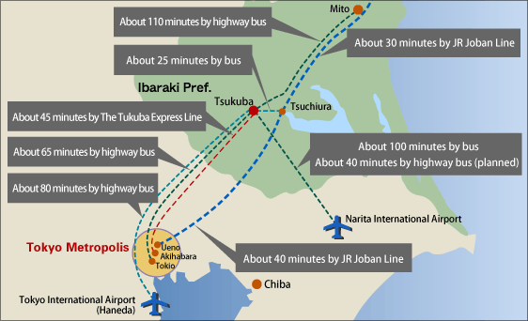
Position of Tsukuba City

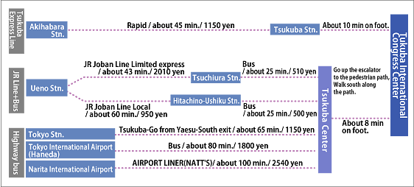
Access to Tsukuba City

Area Map
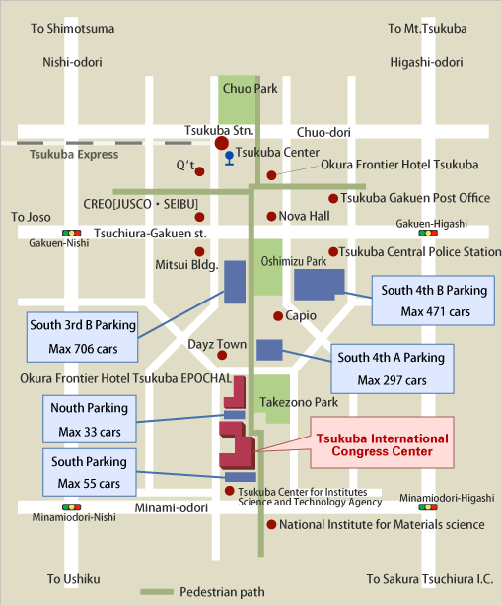

From Tsukuba Station:
Go up the escalator at Exit A3. Turn right at a ticket office, then, go up the front steps. Go straight approximately for 800m.
3. Program
October 17 (Thu) 13:00 – 17:30
1) Invited Lecture 1
Alien weeds in arable crops: problems and solutions
Dr. Shunji Kurokawa (National Agriculture and Food Research Organization)
2) Invited Lecture 2
About the practical use and the penetration of UAV for agrichemical spraying
Dr. Yusasa Kazuyasu (Engineering Section R&D Department, MARUYAMA MFG.CO.,INC.)
3) Banquet 18:00-20:00

October 18 (Fri) 9:30 – 16:00
4) Invited Lecture 3
Challenge and solution of chemical spray to slope orchards by multi-rotors
Prof. Toru Iwanami (Faculty of Agriculture, Tokyo University of Agriculture)
5) Invited Lecture 4
Use of unmanned aerial vehicles for labor-saving pesticide application in
sloped citrus fields
Dr. Shinichi Masui (Fruit Tree Research Center, Shizuoka Prefectural Research Institute of
Agriculture and Forestry)

6) Invited Lecture 5
Organosilicones for Drone Spray Applications
Dr. Jeferson A. Naue (Momentive Performance Materials, USA)

4. Registration
Please fill the attached registration form and send it by mail, fax or e-mail to the following address.

Dr. Kazuhiko Tane
Pesticide Formulation Group, Oppama Research Laboratory
Toho Chemical Industry Co, Ltd.
5-2931, Urago-Cho, Yokosuka-Shi, Kanagawa, 237-0062, Japan
TEL: +81-46-866-5736 FAX: +81-46-866-5731
E-mail: seizaisympo@toho-chem.co.jp

Advance rate fees apply until August 1, 2019.
 | Early bird  By July 31, 2019 | Normal  August 1- October 18, 2019
Members of  the Pesticide Science Society of Japan or the support societies | \14,000 | \21,000
Non-members | \19,000 | \21,000

Registration fee will include cost of the October 17th banquet, lunch on 18th and a booklet of abstracts, and should be paid upon arrival in Japanese currency. In addition, you can pay the registration fee with a credit card by the URL below.

http://biz1.dynacom.jp/cgi-bin/pssj/member/card_general.cgi

5. Accommodations
The secretariat does not organize hotel accommodations. Please make a hotel reservation by yourself.

6. Call for papers

Those who are interested in technical presentation at the symposium should fill in the "Application for presentation" form and send it to the following address of the symposium secretary by June 28.
“15 minutes oral presentation and poster presentation including 3 minutes oral presentation should be subjected on “Agricultural formulation and application”.

Hirokazu Kamatani
Agricultural Chemicals Research Department, Chemical Research Laboratories
Nissan Chemical Corporation
10-1, Tsuboinishi 2-chome, Funabashi-city, Chiba 274-8507, Japan
TEL: +81-47-465-1116 FAX: +81-47-465-5307
E-mail: seizai39@nissanchem.co.jp

Abstract format
Abstract for oral and poster presentation should be made according to the following guidelines and submitted to the above symposium organizer by July 31, 2019.

*Abstracts should be 1-2 pages in length
*80 English words/line, 32lines/page including title, authors and affiliation.
*A checkmark should be placed beside the presenter's name. (Example) ○Ogawa,・・
*Margin Right and left : 20mm
Upper: 20mm
Bottom: 25mm

Presentation Equipment Information
A poster board (100 x 210 cm) will be provided for each poster presentation. A table is also available upon request, at a separate rental charge (JP\30,000).
PC and overhead projectors are available to participants doing oral presentation. MS Power Point is the preferred format for PC presentations and your file of the presentation must be sent to following address by e-mail by September 13 2019.

Hirokazu Kamatani
Agricultural Chemicals Research Department, Chemical Research Laboratories
Nissan Chemical Corporation
10-1, Tsuboinishi 2-chome, Funabashi-city, Chiba 274-8507, Japan
TEL: +81-47-465-1116 FAX: +81-47-465-5307
E-mail: seizai39@nissanchem.co.jp

Abstract format

20 mm

□□□□□ Title 2 lines
4 lines □□□□□ Sub-title （Please start after 10 blanks）
□□□Authors（Affiliation） 2 lines
□□□ (Please start after 6 blanks）
Summary
20 mm 20 mm
80 English words／line×32 lines

32 lines

25 mm Size: A4 Paper
(210 x 297 mm)

Registration Form
The 39th Japan Agricultural Formulation and Application Symposium

NO. Name Affiliation and address including Tel & Fax numbers
１
２
３
４
５
６
７
８
９
１０
 | Total Participants | Total Registration Fee  \

Application for presentation
The 39th Japan Agricultural Formulation and Application Symposium

Presenter：

Affiliation and Address：

TEL： FAX：

Presentation Title ：

Presentation type
- Oral
- Poster (panel only)
- Poster (panel and table)

Deadline: June 28, 2019

